**Kubota Connect (KUB):** Kubota Connect is a NetView Connect application intended to help Kubota dealers communicate with the manufacturer and better access information about Kubota products. **NOTE: Only available to Kubota dealers.**

The application can be accessed by typing **KUB** into the Shortcuts Bar.

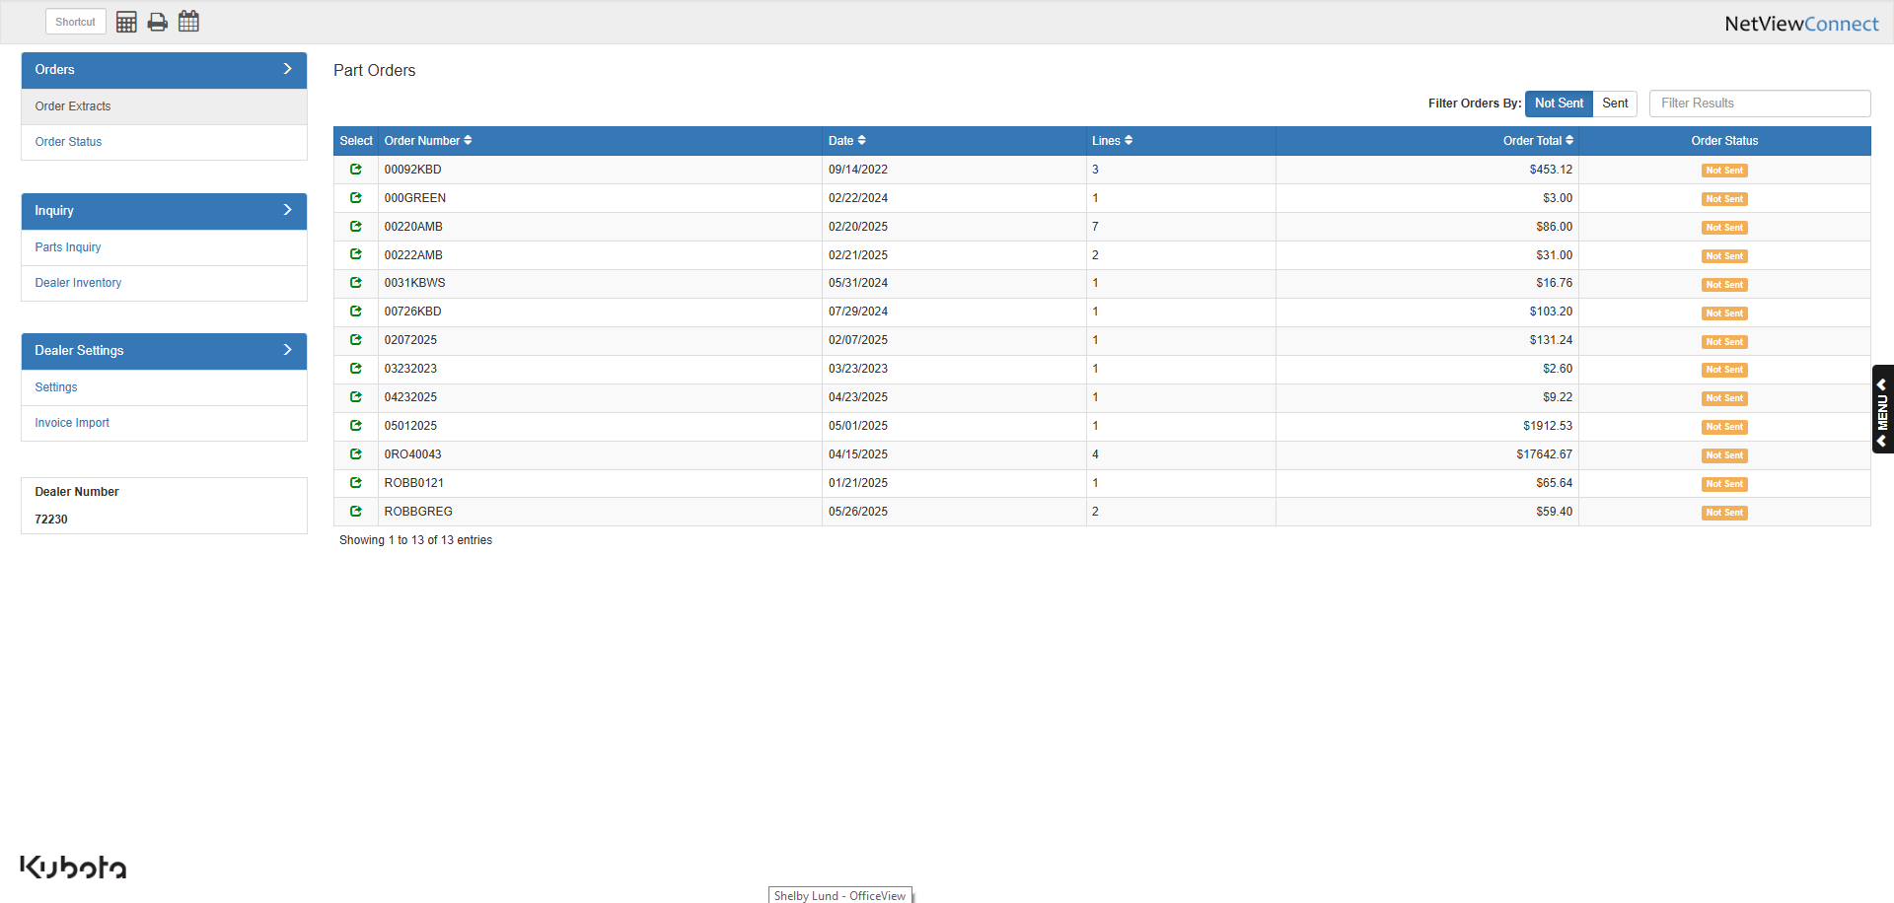

**Settings:** The first time you access the program, you will be asked to input your dealer number to confirm that you are a Kubota dealer.

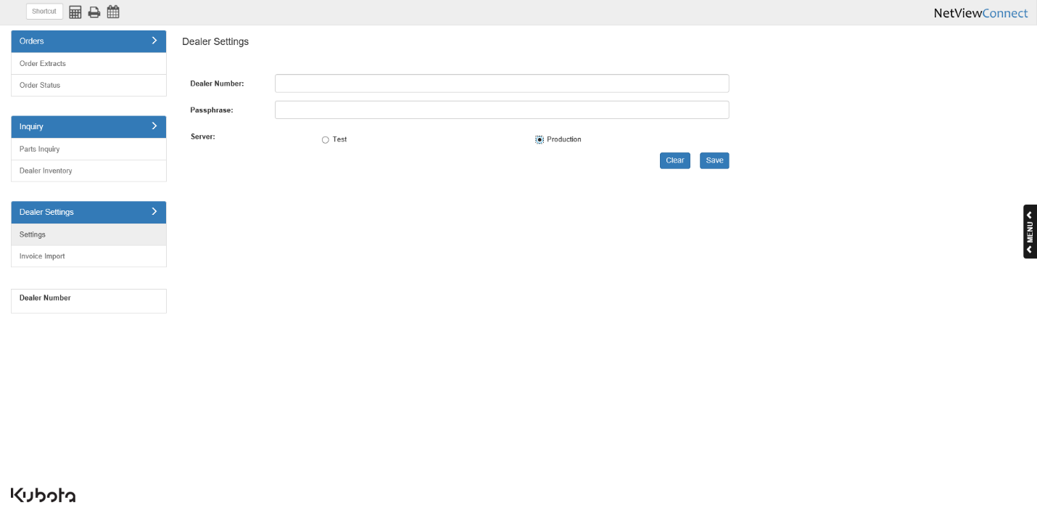

You will only have to type it in once, as the program will store the number for future use, allowing you unrestricted access going forward.

**Invoice Import:** The other settings tab lets you set defaults for the Kubota Invoice Import feature.

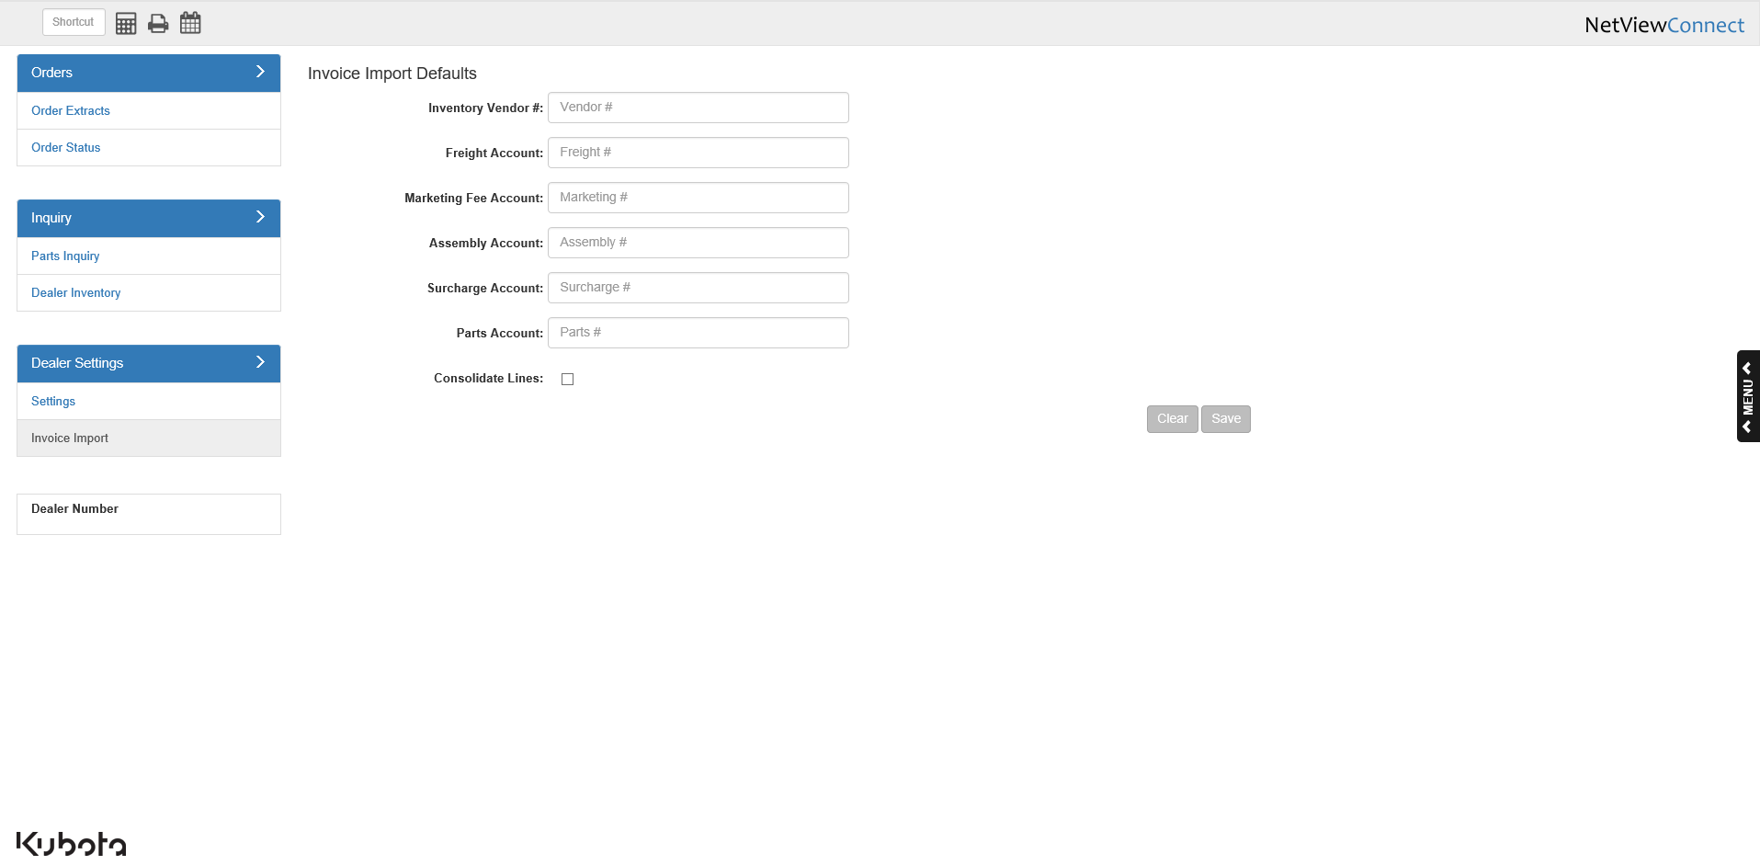

Inventory Vendor #: Use this field to set a default Kubota inventory vendor for your imported invoices. The program will validate the field to ensure you have entered a vendor number that exists in the system.

Freight Account: Use this field to set a default account for freight lines on your imported invoices. The program will validate the field to ensure you have entered an account number that exists in the system.

Marketing Fee Account: Use this field to set a default account for marketing fee lines on your imported invoices. The program will validate the field to ensure you have entered an account number that exists in the system.

Assembly Account: Use this field to set a default account for assembly lines on your imported invoices. The program will validate the field to ensure you have entered an account number that exists in the system.

Surcharge Account: Use this field to set a default account for surcharge lines on your imported invoices. The program will validate the field to ensure you have entered an account number that exists in the system.

Parts Account: Use this field to set a default account for parts lines on your imported invoices. The program will validate the field to ensure you have entered an account number that exists in the system.

Consolidate Lines: Check this box to combine all invoices lines of the same type into a single line on the invoice. For example, if you have ten individual part lines on the invoice, checking this box would combine them into a single line worth the value of all ten parts.

Clear: This button will activate once you make a valid entry in one of the default fields. Click it to clear the fields without saving.

Save: This button will activate once you make a valid entry in one of the default fields. Click it to save your entries.

**Order Extracts:** The program automatically opens to the Order Extracts tab, which shows all open Kubota parts orders.



The screen also has a filter option to let you specifically view which of your orders you have sent to Kubota already, and which ones you have not yet sent. You will see all the orders not yet sent by default.

Submitting an Order: To review an order and prep it for submission to Kubota, click on the green symbol in the Select column.

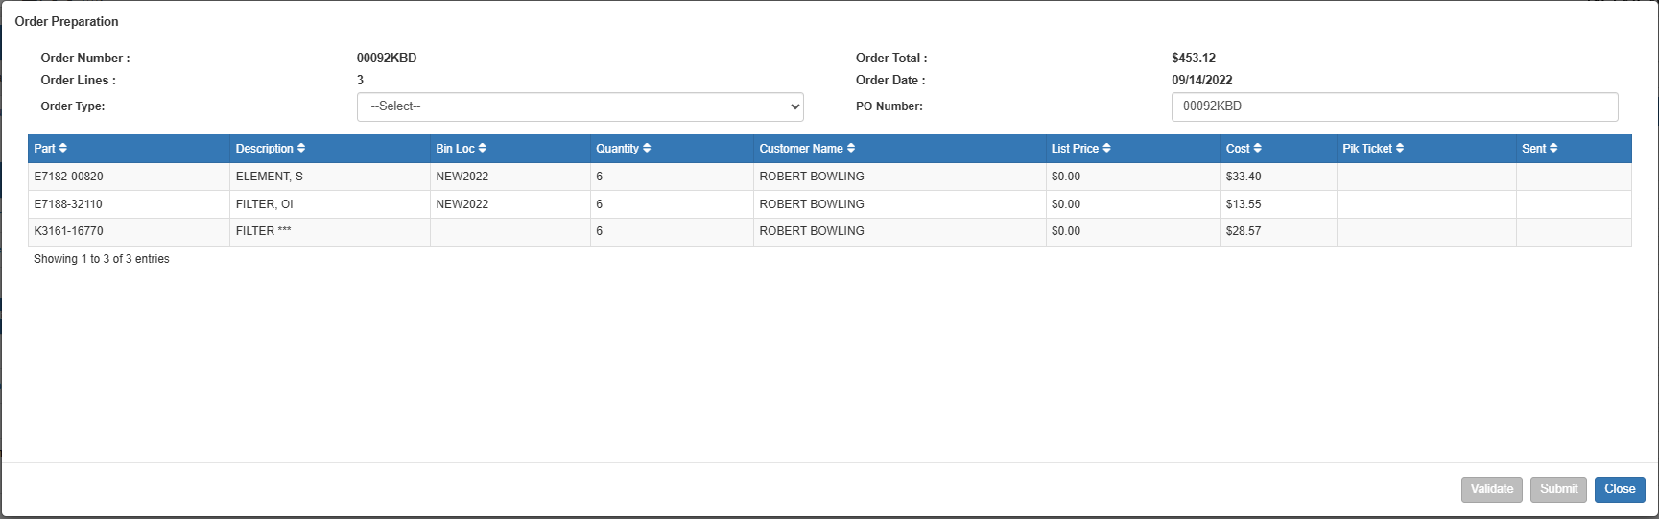

From the Order Preparation screen, you can change the PO number as needed and choose the order type.

* Valid order types are:
  + EM=Emergency
  + PR=Promotional
  + RG=Regular
  + ST=Stock
  + ZDST=Daily Stock
* When you choose **Regular** or **Emergency** order types, there is an optional checkbox for entering a special shipping address. When checked, the screen opens to offer the ability to enter the shipping address for the order. You may:
  + Enter a shipping address in the fields provided and validate it against the customer file
  + Look up a customer address from the system (click on **Lookup Address** and search for the customer).

Validate: When you have the order type selected and optionally entered the shipping address, you may validate the information before the order is submitted by clicking on the **Validate** button. The validation step provides the following:

* A validation message showing either (see below images):
  + Success

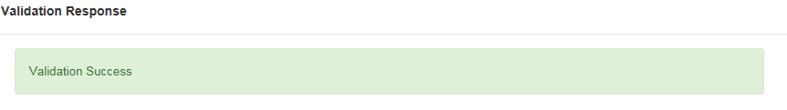

* + A reason why the order is not valid

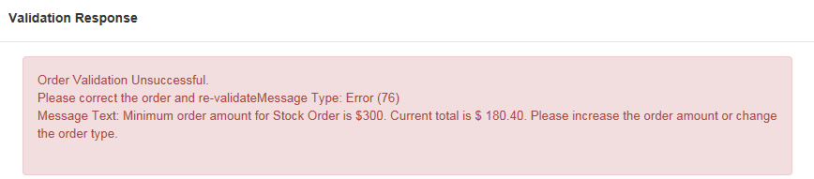

* Dealership name
* Dealer number
* Total cost of order date
* Billing info
* Ship-to address info

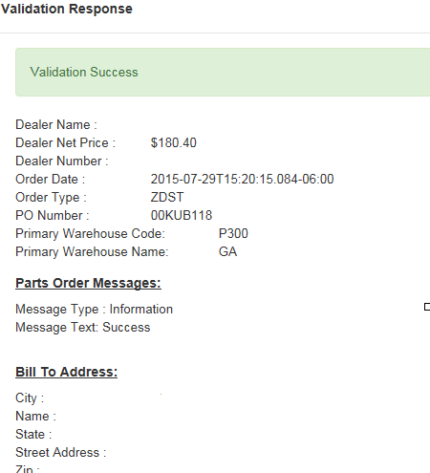

Each order line item is also reported with details like those shown below.

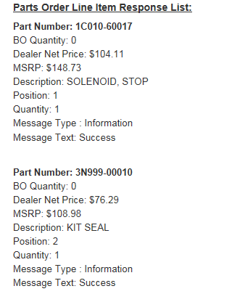

Finishing the Order: When ready, click **Submit** to send the order to Kubota.

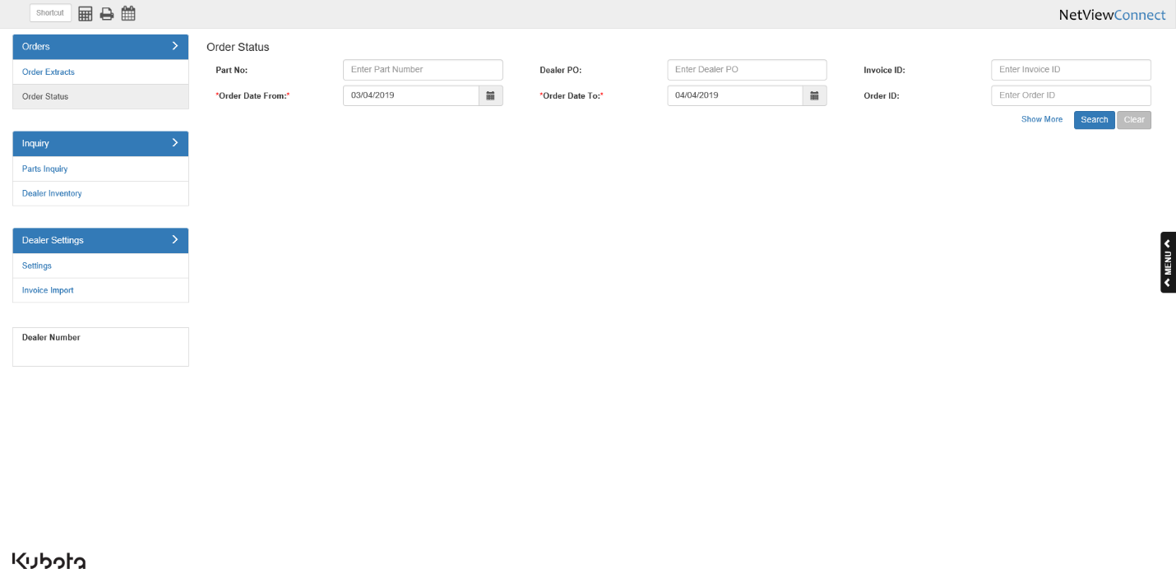

**Order Status:** The Order Status screen initially opens with order search options for:

* Part Number
* Order Date
* Dealer PO
* Invoice ID
* Order ID

Show More: Click on “Show More” to enhance the search options to include:

* Order Type
* Ship Date
* Warehouse
* Status
* Ship Via
* Tracking Number

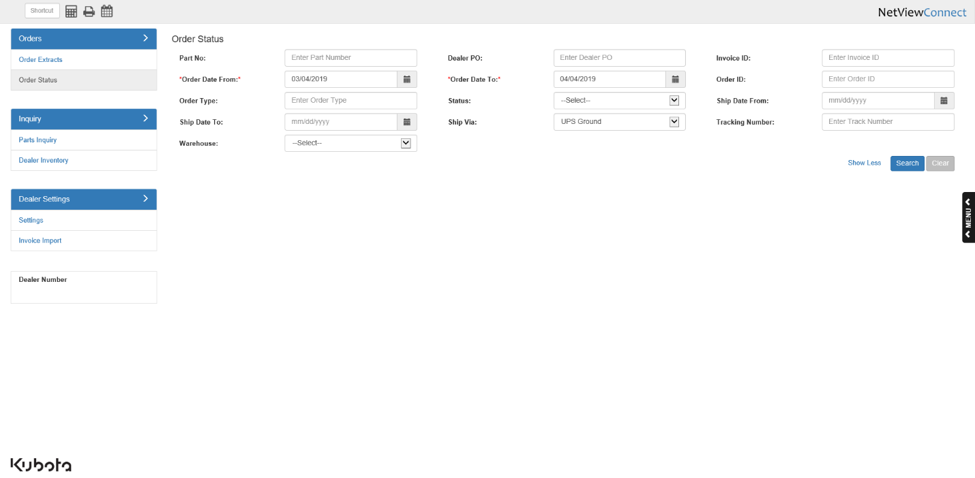

Search Results: The inquiry returns information based on the details sent.

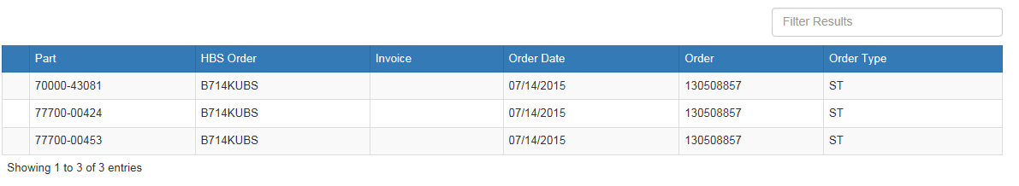

In addition, you can click on any given line and get detailed info for that particular part number.

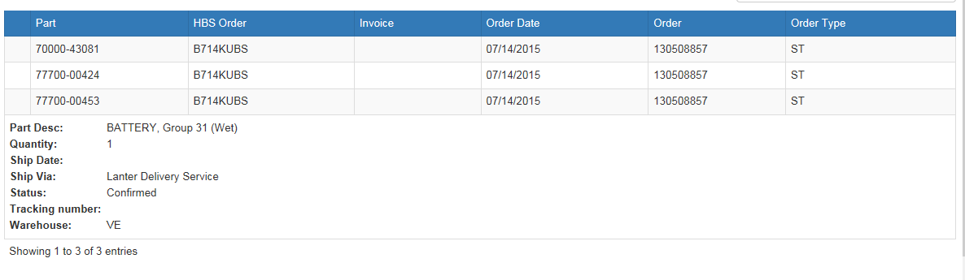

**Parts Inquiry:** This tab allows you to look up information on Kubota parts.

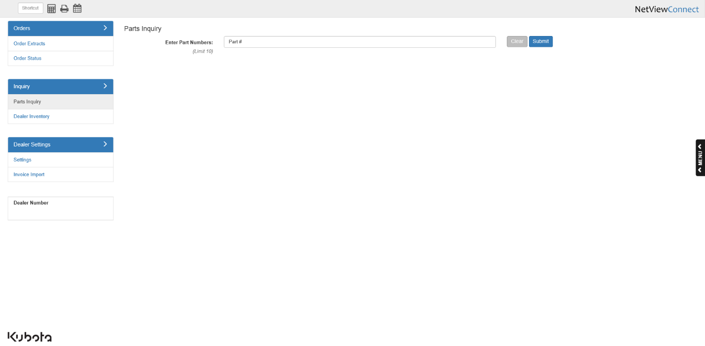

Enter a Kubota part number and click **Submit**. **NOTE:** You can look up more than one part at a time by typing in a part number, hitting the “Enter” key, and repeating until you have all the parts you want to look up.

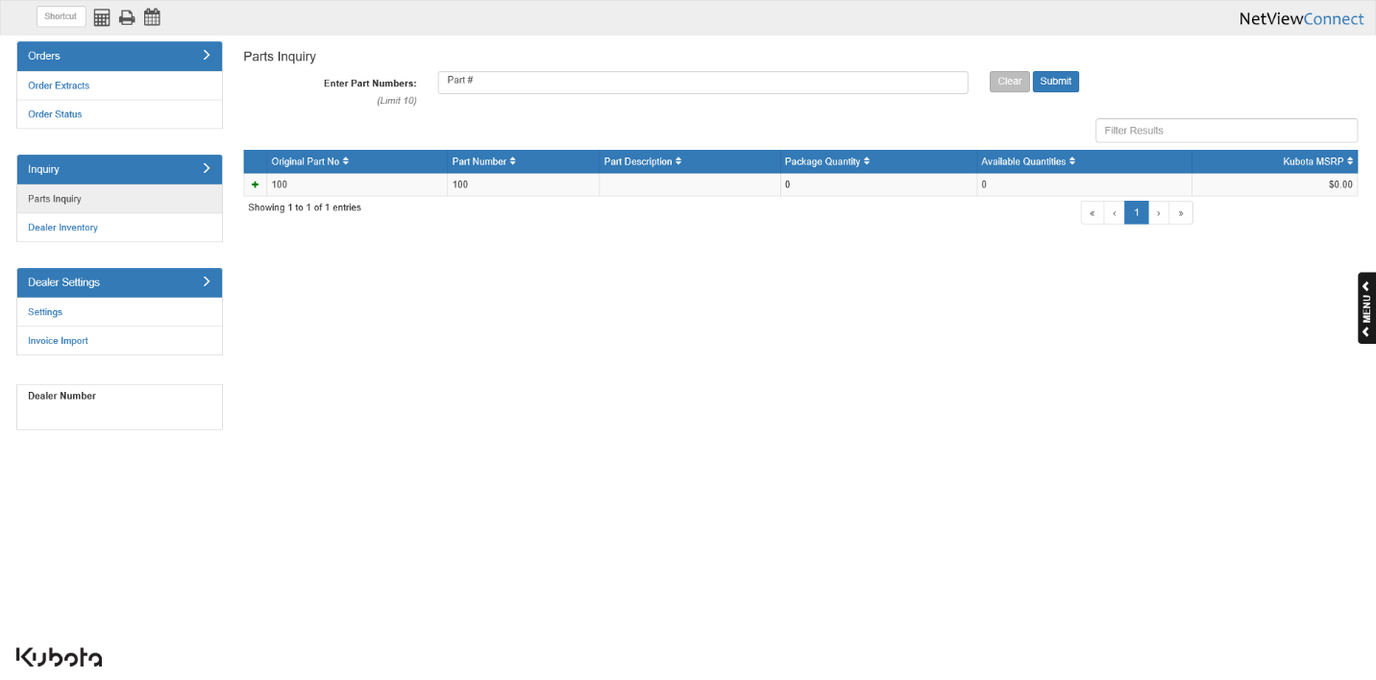

The inquiry will list the following:

* Original part number
* Part number
* Part description
* Package quantity
* Available quantities
* Kubota MSRP

Click the green (+) in the far left column to view the part’s available quantities at specific warehouses.

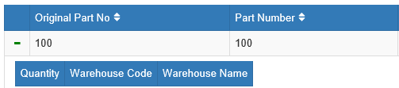

**Dealer Inventory:** Aside from being able to perform a Parts Inquiry in this program, you can also do a Dealer Inventory search.

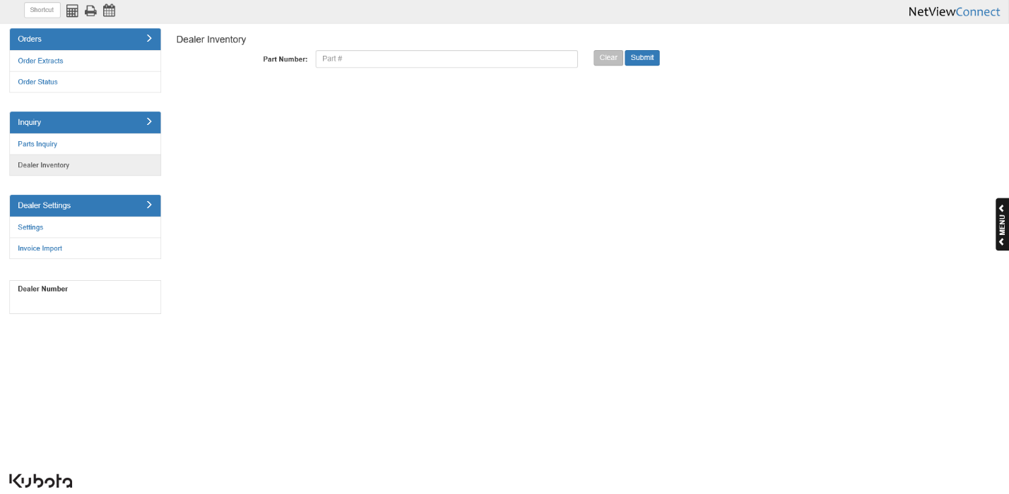

Enter a Kubota part number and click **Submit**. The search will show:

* The dealers who have that part number
* The quantity they have on hand
* Their contact info

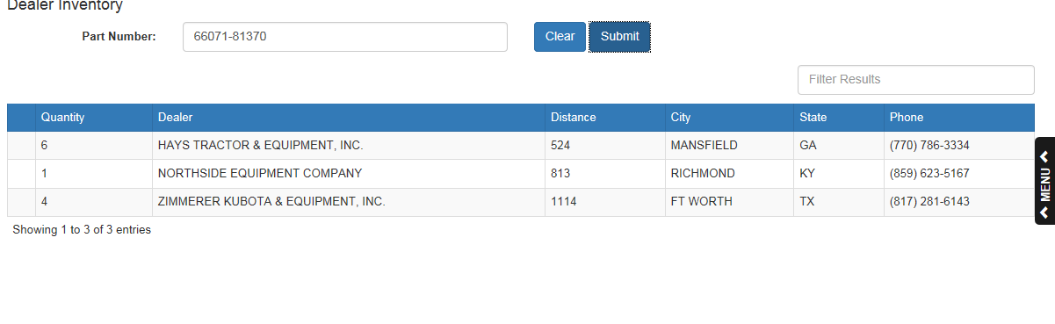

**Fast Inquiry:** The Fast Inquiry function (Shift F12) allows you to do an immediate parts inquiry to Kubota. This feature is available inside the following programs:

* **Parts Inquiry (PI)**
* **Quick Order Adjustments (QOA)**
* **Price File Inquiry (PFI)**

Accessing Fast Inquiry: To access the feature:

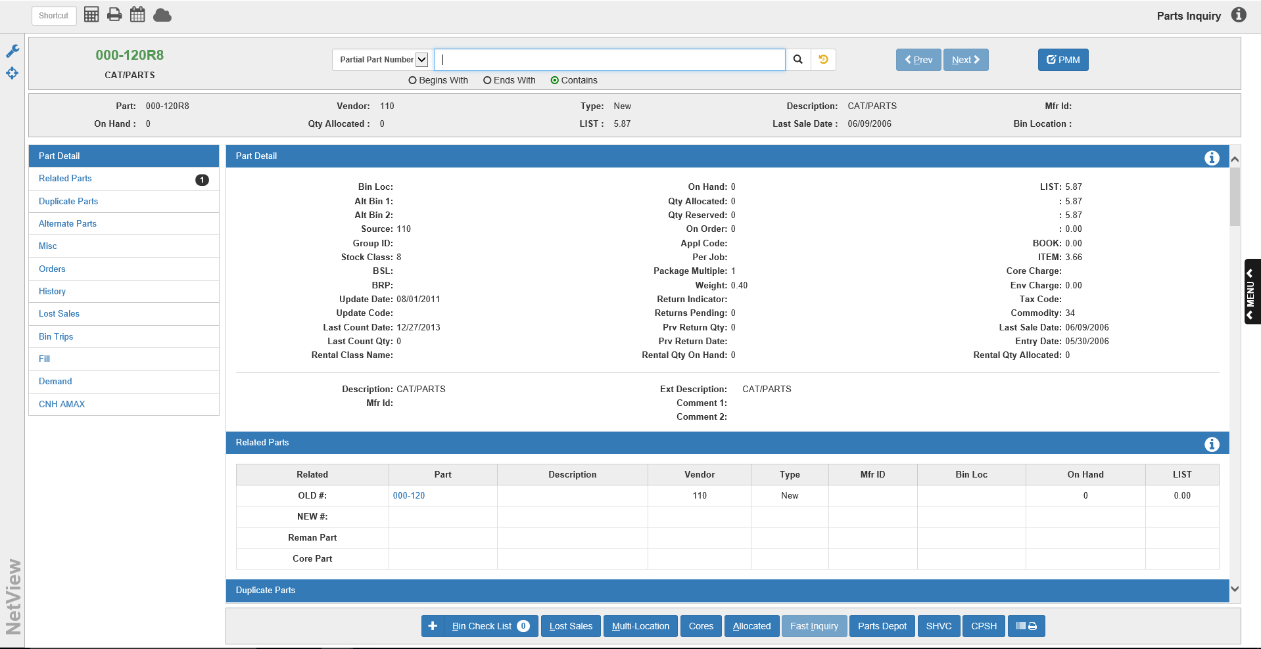

**In Parts Inquiry (PI):**

* Fill in a Kubota part number
* Click **Fast Inquiry**.

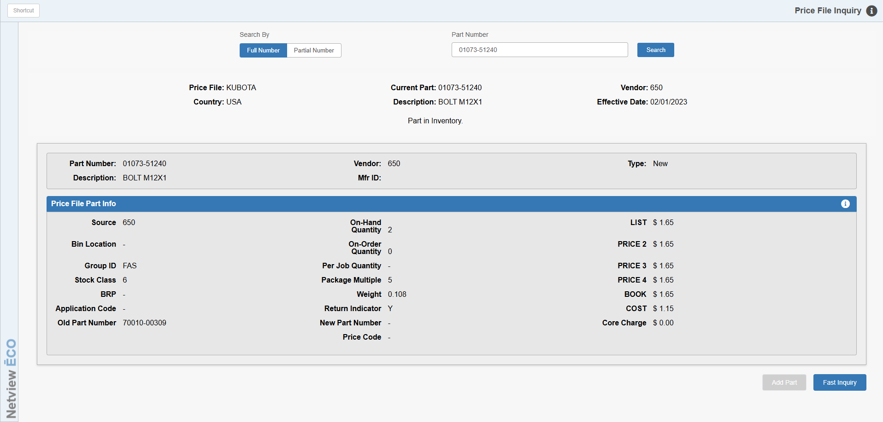

**In Price File Inquiry (PFI)**

* Enter a Kubota part number.
* Click **Fast Inquiry**.

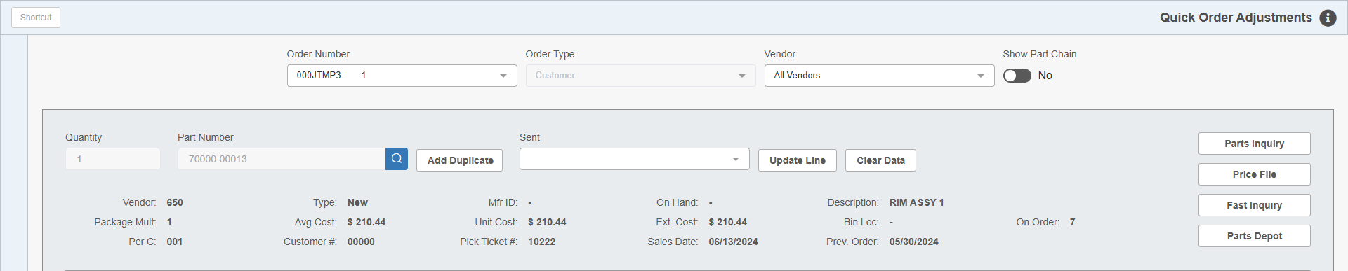

**In Quick Order Adjustments (QOA)**

* Enter a Kubota part number.
* Click **Fast Inquiry**.

Using Fast Inquiry: The resulting screen shows as below:

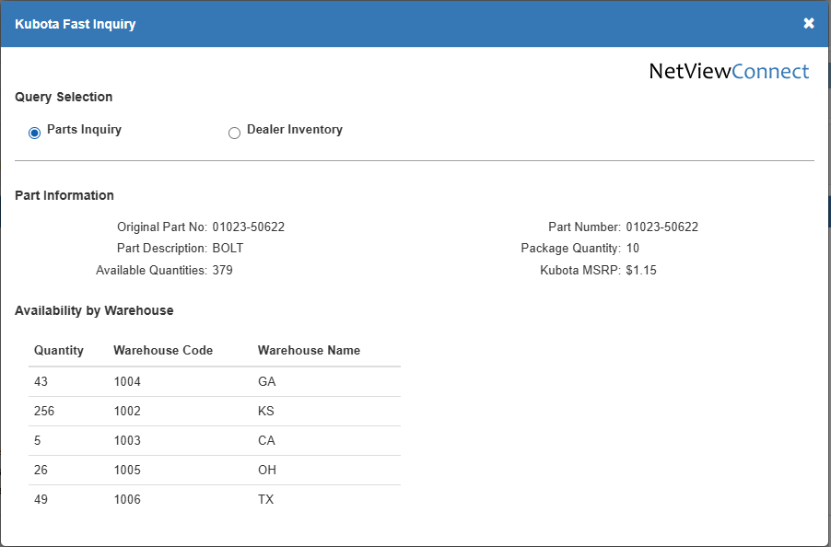

**Parts Inquiry:** The inquiry initially returns the Parts Inquiry info. This includes:

* Original part number
* Description
* Package quantity
* Available quantities at Kubota, shown by:
  + Warehouse Code
  + Name
* Unit Cost

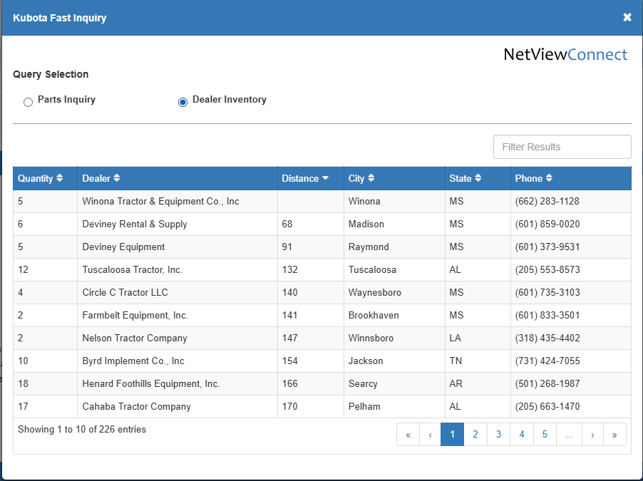

**Dealer Inventory:** Click on “Dealer Inventory” to find the part number in a dealer’s inventory. The Dealer Inventory info includes:

* The quantity they have
* The dealer’s name
* The dealer’s distance from your dealership
* The city
* The state
* The dealer’s phone number.